8.LINEAR SERACH

**Aim**

To write a C program to search for an element in an array using **Linear Search**.

**Algorithm**

1. Start.
2. Read the array size n and elements.
3. Read the element to search (key).
4. Traverse the array from index 0 to n-1:
   * If arr[i] == key, print position and stop.
5. If not found, display "Element not found".
6. Stop.

PROGRAM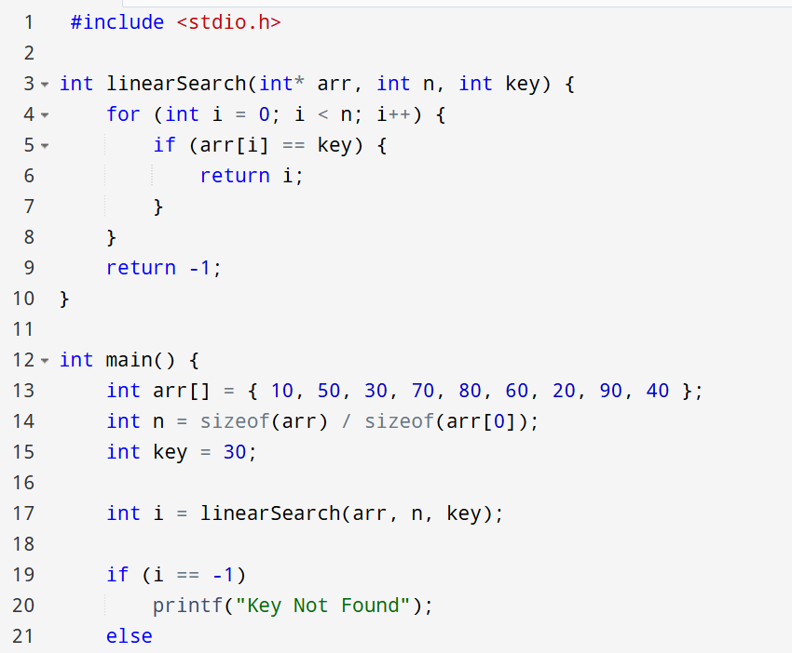

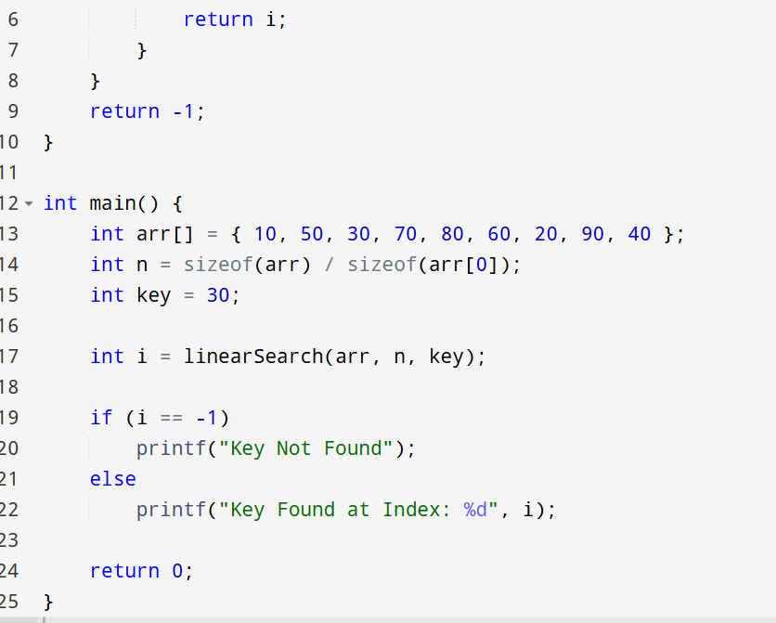

OUTPUT

